Q#1) Define charge density
When the charges are continuously over a region-a line, the surface of a material, or inside a sphere-we must specify the charge density. Depending upon how many dimensions the region has, we define:
(a) For linear charge distribution: 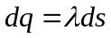
(b) For surface charge distribution: 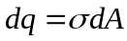
(c) For volume charge distribution: 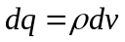
The dimensions of are determined from the above definitions.
Q#2) Define Gauss’s Law?
Ans: The total electric flux leaving a closed surface is equal to the charge enclosed by the surface divided by 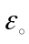.We can expressed in mathematics form 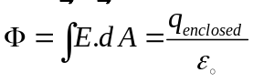
Q#3) Define electric potential?
Ans: The electric potential is the energy of a unit charge in an electric field. So in our MKS units the unit of potential is 1Joule/Coulombs=1Volt.Another useful unit is 1Electron Volt.
Q#4) Define 1Ev?
Ans:- One electron-volt=enrgy gained by moving one electron charges through one volt.
=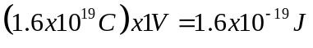
It is useful to note that
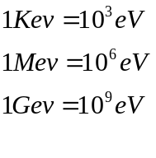
Q#5) Given a system of charges, we can always compute the force - and hence the potential -
That arises from them. Here are some important general statements:
a) Potentials are more positive in regions which have more positive charge.
b) The electric potential is a scalar quantity (a scalar field, actually).
c) The electric potential determines the force through F=− du/dr, and hence the electric
Field because F= qE.
d) The electric potential exists only because the electrostatic force is conservative
Q#6) Define Capacitor?
Ans:- Two conductors isolated from one another and from their surroundings, from a capacitor. These conductors may be of any shape and shape, and at any distance from each other.
If a potential difference is created between the conductors (say, by connecting the terminals of a battery to them), then there is an electric field in the space between them. The electric field comes from the charges that have been pushed to the plates by the battery. The amount of charge pushed on to the conductors is proportional to the potential difference between the battery terminals (which is the same as between the capacitor plates). Hence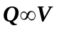. To convert this into equality, we write 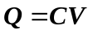 . This provides the definition of capacitance,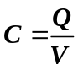
Q#7) Define Ampere?
Ans:- Electric current is the flow of electrical charge. If a small amount of charge 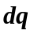 flows in time dt, then the current is 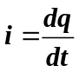 . If the current is constant in time, then in time t, the current that flows is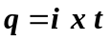. The unit of charge is ampere, which is defined as:
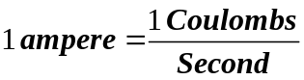
A car’s battery supplies up to 50 amperes when starting the car, but often we need to deal with smaller values:
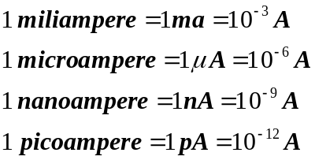
Q#8) Define Resistance?
Ans:- Resistance is directly proportional to the voltage V and inversely proportional to the current I.
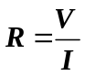
Imp:-
When resistors are put in series with each other, the same current flows through both.
When current flows in a circuit work is done.
Q#9) Unit and definition of power?
Ans:- This is an important formula. It can also be written as 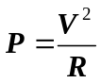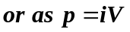.The unit of power is: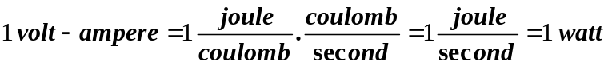
Q#10) Define Kirchhoff’s Law
Ans: - The sum of the potential differences encountered in moving around a Closed circuit is zero.
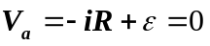
Q#11) Define magnetic field
Ans: - The magnetic field exerts a force upon any charge that moves in the field. The greater the size of the charge, and the faster it moves, the larger the force. The direction of the force is perpendicular to both the direction of motion and the magnetic field. If is the angle between 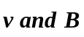 then 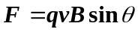 is the magnitude of force.
The unit of magnetic field that is used most commonly is the tesla. A charge of one Coulomb moving at 1 meter per second perpendicularly to a field of one tesla experiences
a force of 1 Newton tesla. Equivalently,
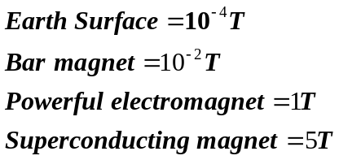
Q#12) Define Lorentz force
Ans:- When both magnetic and electric fields are present at a point, the total force acting upon a charge is the vector sum of the electric and magnetic forces,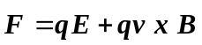.This is called Lorentz force.
Q#13) Define Weber?
Ans: - The dimension of flux is magnetic field x area, and the unit is called Weber.
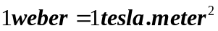
Q#14) Define alternating current
Ans: - Alternating current (AC) is current that flows first in one direction along a wire, and then in the reverse direction.
Q#15) Red Light has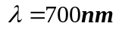.The frequency can v can be calculated as?
Ans:-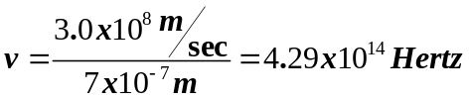
Q#16) Define Emission?
Ans: - Matter releases energy as light.
Q#17) Define Absorption?
Ans: - Mater takes energy from light.
Q#18) Define Transmission?
Ans:- Matter allows light to pass through it.
Q#19) Define Reflection?
Ans: - Matter repels light in another direction.
Q#20) Define Diffraction?
Ans: - The bending of light around objects (into what would otherwise be a shadowed region) is known as diffraction. Diffraction occurs when light passes through very small apertures or near sharp edges.
Q#21) Define statically mechanics
Ans: - The study of heat, considered as arising from the random motion of the basic constituents of matter, is an area of physics called statistical mechanics.
Q#22) what are the lifetime of the polonium, krypton, strontium, radium, carbon and uranium?
Ans: -
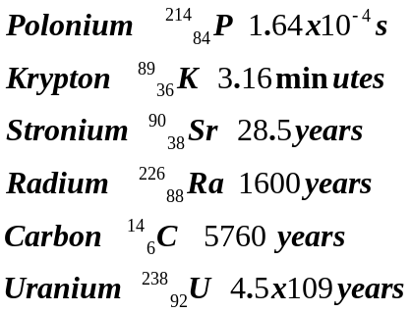

Q#23) what are the basics solar facts?
Ans: -
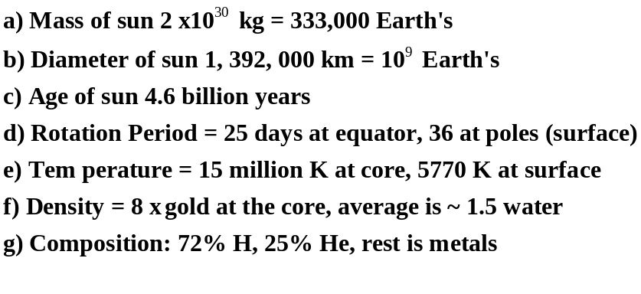
Q#24) In a cool room, a metal or marble table top feels much colder to the touch than does a wood surface even though they are at the same temperature. Why?

Search Results

Because metal and stone conduct heat better than wood. Skin temperature is higher than room temperature, so when we touch metal, we give heat more quickly to the metal than wood. Another reason is that metal and stone store more energy than a like sized object of wood

Q#25) Initial is pushing but the box does not move. What is the force of static friction shown in below figure?

If there is no relative motion between objects in contact, then the friction force (if there is ... When the truck accelerates and the box moves with ... directed opposite to the way you are walking, but the force of static friction ... shown in Figure 5.2. ... Step 2 - What is the force of friction acting on the box if you push horizontally on.
Q#26) is it true to say that Centre of mass and Centre of graving are the same? Either yes or no explain in each case.

Many people assume that the terms “centre of mass” and “centre of gravity” are synonymous, but this is not the case. ... The centre of mass and the centre of gravity of an object are in the same position if the gravitational field in which the object exists is uniform.
Q#27) Describe a few examples in which the force of friction exerted on an object is in the direction of motion of the object.

Example is an object travelling with a moving object. If you are on a train, the relative motion of you to the train is backward because you don't move.
Q#28) Is it possible for two objects to be in thermal equilibrium if they are not in content with each other? Explain.

According to the law of thermodynamics, the two objects which are not in contact with each other may be in thermal equilibrium.
Q#29) Wave spend in a string is a fiction of frequency, so if the wave frequency, will the wave speed increase to?
Ans If speed = frequency * wavelength. ... That means speed is directly proportional to frequency. When frequency increases, speed increases and vice versa.
Q#30) A 2000kg car is moving with a velocity of 20 m/s collides and locks with a 1500 kg car at rest a stop sign. Show the momentum is conserved.
A 2000-kg car moving with a speed of 20 m/s collides with and sticks to a 1500-kg car at rest at a stop sign. Show that because momentum is conserved in the rest frame, momentum is also conserved in a reference frame moving with a speed of 10 m/s in the direction of the moving car
Q#31)
Light from sun takes approximately 8.3 min to reach the earth during the earth is rotating with the constant speed continuously. How far is the actual direction of the sun?
Ans:
z = 149.4 million km.

Explanation:
This is fairly simple you just have to remember a simple equation.
z = c * t
if you know the time that light takes to reach us then you can calculate the distance to that object and vice versa.
In the above equation,
z is the distance to the object.
t is the time light takes from the object to reach us
c is the speed of light which is always constant about 300,000 km/ sec.
The time light takes to reach us from the Sun is about 8.3 minutes.
z = 8.3 * 300,000
Note that the speed of light is in units of km/ sec so we will have to convert minutes into seconds.
1 minute = 60 seconds
8.3 minutes = 8.3 * 60
8.3 minutes = 498 seconds.
z = 498 * 3
z = 149400000 km
OR
z = 149.4 million km.

Q#32) Do all current-carrying conductors emit electromagnetic waves?
... Yes all current carrying conductors emit electromagnetic waves, and these are at the right angle of the current passes through as right hand rule of Fleming's explains it.
Q#33)If you hold water in a paper cup over flame, can you bring the water to boil, if then how?

Just fill a paper cup with water and start trying to burn it from the outside. The water will boil vigorously inside the cup, but the paper itself wills not combust. ... The boiling water can't get above 212 degrees, and the paper is thin enough that this water keeps its temperature from climbing high enough to combust.
Q#34) All objects radiate energy then why are we not able to see all the objects in the dark?

Our eyes are not sensitive to infrared radiation so we do not see it. Cold bodies radiate mostly in the infrared zone (invisible to the human eye), but as the temperature increases the body will emmit higher frequencies with more intensity. So room temperature objects will not be seen due to black body radiation.

Q#35) If an electron and proton have same De Broglie’s wavelength, which particle has greater speed
The de Broglie wavelength of a particle is inversely proportional to its momentum p = m v; since a proton is about 1800 times more massive than an electron, its momentum at the same speed is 1800 times that of an electron, and therefore its wavelength 1800 times smaller. The electron has the longer wavelength.

Search Results

Q#36) Explain why mercury rises in thermometer when is it put in the hot water?
It consists of a bulb containing mercury which is then attached to a narrow glass tube. As temperature rises, the level of mercury in the tube increases. This happens because the volume of mercury slightly increases with temperature.

Q#37) Why is glass transparent to visible light but opaque to UV light?
Beyond the range of UV light (wavelength >400 nm), the energy of visible and infrared light are not enough to excite the electrons and most of the incident light gets transmitted. Thus glass appears transparent to visible and infrared light
Q#38) If a120v line to a socked is limited to15a by a safety fuse will it operate a 1200w hair dryer?
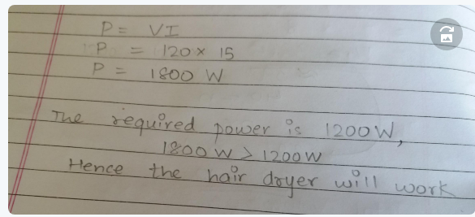

Q#39) wearing a metal bracelet in a region of strong magnetic filled could be hazardous?
Answer. As the bracelet is metallic it will be pulled towards the strong magnetic force acting around it, and you can also be pulled with the bracelet if the force is strong enough which can cause ham to you.
Q#40) what is the changing in entropy of 1mol of water at0c that freeze?

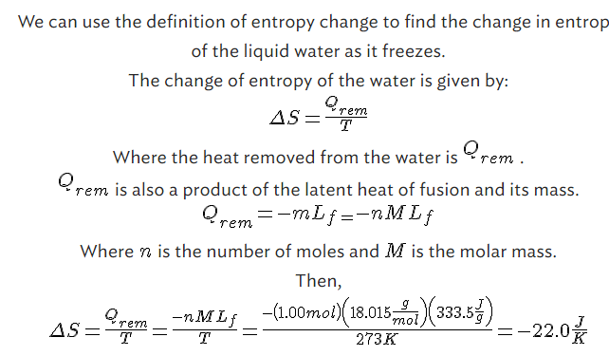

Showing results for explain the fusion reactions sun?
Inside the Sun, this process begins with protons (which is simply a lone hydrogen nucleus) and through a series of steps. These protons fuse together and are turned into helium. This fusion process occurs inside the core of the Sun, and the transformation results in a release of energy that keeps the sun hot.
If a total charge inside a surface is known but the distribution of the charge is unspecified can u use the cause?
No. We can’t find the electric field if we don't know the exact charge distribution. This is because symmetry might not be there and we can’t use Gauss theorem.
Law to find the electric field all object radiate energy?
The experimental Stefan's law states that the total power of radiation emitted across the entire spectrum of wavelengths at a given temperature is proportional to the fourth power of the Kelvin temperature of the radiating body.

is Heisenberg’s uncertainly principal a case of using the meter to measure the temperature of glass of water?
For example, for a thermometer to measure the temperature of a glass of water, it is put into thermal contact with the water. Heisenberg's uncertainty principle , however, is not the same as the observer effect ... When you are studying the movement of electrons, this ceases to be the case

Do you think light was wave nature and particle nature .give strong reason?
Dual nature of light as "both a particle and a wave" has been proved. it’s essential theory was further evolved from electromagnetic into quantum mechanics. Einstein believed light is a particle (photon) and the flow of photons is a wave.
Do you agree or not that stationary charge or steady current can produce electromagnetic waves?

Maxwell's four equations describe how electric charges and currents create electric ... that there are no “magnetic charges” analogous to electric charges, and that ... waves are the combination of electric and magnetic field. waves produced by both electric and magnetic fields in an electromagnetic wave will fluctuate in

Do you agree or not that stationary charge or steady current can produce electromagnetic waves?
An electromagnetic wave can be created by accelerating chargers. Charges moving back and forth will produce oscillating electric and magnetic fields and these travels at the speed of light.
Stationary charges and constant currents are not accelerating. Hence it cannot produce electromagnetic waves.
What happens to current in other lamps if one lamp in a series circuit burns out?

The same current flows through each part of a series circuit. If the circuit is broken at any point there won't be any current that will flow. ... In this case, if one of the bulbs blew out, the other bulb would not be able to light up because the flow of electric current would have been interrupted.

Given that electrons behave like waves, how is droppler shift described in terms of momentum.
Today, this idea is known as de Broglie's hypothesis of matter waves. ... a new theory of wave quantum mechanics to describe the physics of atoms and ... and momentum is a de Broglie wave of frequency f and wavelength λ: ... that an electron in a hydrogen atom behaves not like a particle but like a wave.

